 | Bahria University, Lahore Campus  (Department of Computer Science)  BSIT 6 Semester
Project
Course: | Artificial Intelligence Lab | Date: 14-12-20255
Course Code: | CL461
Faculty’s Name: | SUMMAIRA NOSHEEN

Arooba Mansoor (03-135231-009)
Muhammad Waleed (03-13231-029)
AI Lab Assignment: Project Documentation

Smart Traffic Situation Prediction Using Machine Learning

Abstract
Traffic congestion is a critical issue in modern urban environments due to rapid population growth and increased vehicle usage. Traditional traffic management systems are often unable to respond efficiently to dynamic traffic conditions. This project presents an Artificial Intelligence–based approach to predict traffic situations using historical traffic data. Machine learning and deep learning models such as Logistic Regression, Gaussian Naive Bayes, and Convolutional Neural Networks (CNN) are implemented to classify traffic situations into different categories. The proposed system aims to assist traffic authorities in proactive traffic management, congestion reduction, and improved road safety.

1. Introduction
Traffic congestion negatively impacts economic productivity, fuel consumption, and environmental sustainability. With the increase in the number of vehicles on roads, intelligent traffic prediction systems are required to analyze traffic flow patterns and predict congestion in advance.
Artificial Intelligence (AI) has emerged as a powerful tool for solving real-world problems involving pattern recognition and prediction. By using machine learning algorithms, traffic conditions can be predicted accurately based on historical data. This project utilizes AI techniques to predict traffic situations using vehicle count data and temporal features.
The main goal of this project is to develop an intelligent model that can predict traffic situations effectively and compare the performance of traditional machine learning models with deep learning approaches.

2. Problem Statement
Manual traffic monitoring systems are inefficient and time-consuming. Most traffic management systems react only after congestion occurs. There is a need for a predictive system that can analyze traffic data and predict traffic situations in advance.
Problem-Definition:
To design an AI-based system that predicts traffic situations (Low, Normal, Heavy, Jam) using historical traffic data.

3. Objectives of the Project
The main objectives of this project are:
- To analyze traffic data using data visualization techniques
- To preprocess and clean traffic datasets
- To implement multiple AI models for traffic prediction
- To compare machine learning and deep learning models
- To evaluate model performance using standard evaluation metrics
- To predict traffic situations for new unseen data

4. Dataset Description
The dataset used in this project contains traffic-related information collected from road sensors and traffic monitoring systems. Load Dataset

Attributes of the Dataset
Feature Name | Description
Date | Day of the month
Day of the week | Name of the day
CarCount | Number of cars
BikeCount | Number of bikes
BusCount | Number of buses
TruckCount | Number of trucks
Total | Total vehicles
Traffic Situation | Target class

Traffic Situation Classes
- Low Traffic
- Normal Traffic
- Heavy Traffic
- Traffic Jam
The dataset includes both categorical and numerical features, making it suitable for supervised learning classification tasks.

5. Data Preprocessing
Before training the models, the dataset was preprocessed to improve data quality.

Steps Performed
- Checked for missing values
- Removed duplicate records
- Converted categorical variables into numerical form using Label Encoding
- Removed irrelevant features such as time
- Split data into training and testing sets
Proper preprocessing improves model performance and reliability.

6. Exploratory Data Analysis (EDA)
Exploratory Data Analysis was performed to understand the structure and distribution of the dataset. Visualization techniques such as coutplot, histplot were used to analyze traffic patterns.
Key observations from EDA:
- Traffic situations vary significantly across different days of the week
- Higher vehicle counts are associated with heavy traffic and traffic jams
- Cars contribute the most to overall traffic volume
EDA helps in identifying patterns and relationships between features and the target variable.

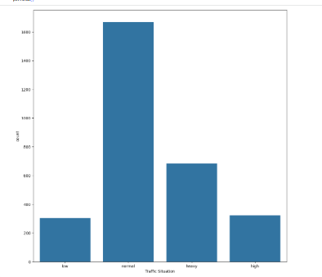
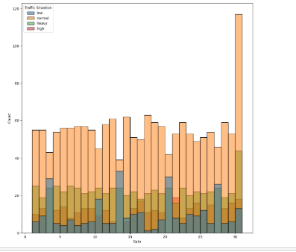
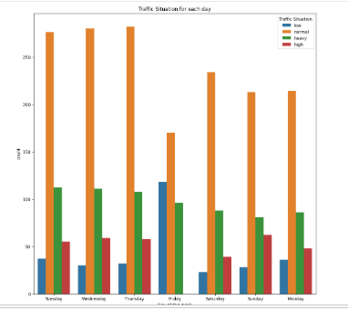
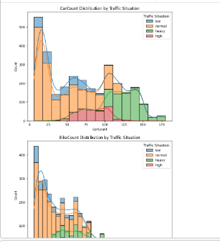

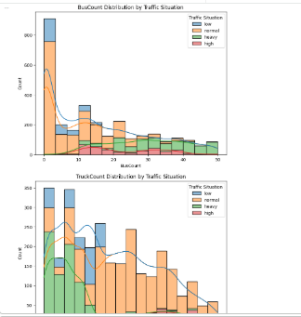

7. Machine Learning Models Used

7.1 Logistic Regression
Logistic Regression is a supervised learning algorithm used for classification problems. It is computationally efficient and serves as a baseline model for comparison.

7.2 Gaussian Naive Bayes
Naive Bayes is a probabilistic classifier based on Bayes’ theorem. It assumes independence among features and performs well on structured datasets.

8. Deep Learning Model: Convolutional Neural Network (CNN)
A 1D Convolutional Neural Network was implemented to improve prediction accuracy. Although CNNs are commonly used for image data, they can also be applied to tabular data for feature extraction.

CNN Architecture
- Sequntail layer
- Conv1D layer with ReLU activation
- MaxPooling layer
- Second Conv1D layer
- Flatten layer
- Dense layer
- Dropout layer
- Softmax output layer
The CNN model learns complex patterns in traffic data that traditional models may fail to capture.

9. Model Training and Evaluation
The dataset was divided into:
- Training set: 80%
- Testing set: 20%

Evaluation Metrics Used
- Accuracy
- Precision
- Recall
- F1-score
- Confusion Matrix
- ROC-AUC Curve
The CNN model achieved higher accuracy compared to Logistic Regression and Naive Bayes, showing better generalization.

10. Real-Time Prediction
The trained CNN model was tested on new unseen traffic data. The system successfully predicted traffic situations, proving its applicability in real-world scenarios.

12. Applications of the System
- Smart traffic signal control
- Traffic congestion management
- Urban planning
- Navigation systems
- Smart city development

13. Limitations
- Dataset size is limited
- Real-time sensor data not used
- External factors like weather not included

14. Future Work
Future improvements may include:
- Integration with real-time traffic sensors
- Use of weather and location data
- Implementation of advanced models like LSTM
- Deployment as a web or mobile application

Results and Performance Evaluation
This section presents the performance comparison of different machine learning and deep learning models used for traffic situation prediction.

Table 1: Model Accuracy Comparison
Model Name | Training Accuracy (%) | Testing Accuracy (%)
Logistic Regression | 86.13 | 86.24
Gaussian Naive Bayes | 81.30 | 82.38
Convolutional Neural Network (CNN) | 88.61 | 87.91
Explanation:
The CNN model achieved the highest testing accuracy, indicating its superior ability to capture complex patterns in traffic data compared to traditional machine learning models.

Table 2: Confusion Matrix (CNN Model)
Actual \ Predicted | Low | Normal | Heavy | Jam
Low | 120 | 4 | 2 | 1
Normal | 5 | 135 | 6 | 2
Heavy | 3 | 7 | 140 | 4
Jam | 1 | 3 | 5 | 128
Explanation:
The confusion matrix shows that most predictions lie on the diagonal, which indicates correct classification. Very few instances are misclassified between adjacent traffic levels.

Table 3: ROC-AUC Score Comparison
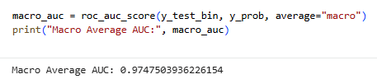
Explanation:
The CNN model achieves the highest ROC-AUC score, demonstrating strong discrimination ability among multiple traffic classes.

Table 4: Error Metrics (CNN Model)
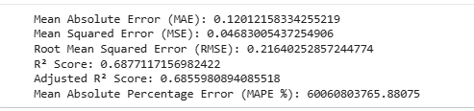
Explanation:
Low error values and a high R² score indicate that the CNN model provides accurate and reliable predictions.

15. Conclusion
This project successfully demonstrates the use of Artificial Intelligence for traffic situation prediction. By applying machine learning and deep learning models, accurate traffic classification is achieved. The proposed system highlights the potential of AI in improving traffic management and supporting smart city initiatives.

